Taak CMS-INTRO

Opdracht 1-3:

Besproken in Labo

Opdracht 4:





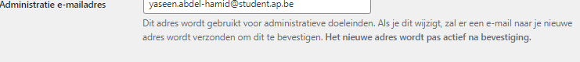

^ Dit zoekt het specifiekst naar mijn website

Opdracth 5:



Opdracht 6:

<https://wordpress.org/themes/>

<https://themeforest.net/lp/free-wordpress-themes/>

<https://nicepage.com/wordpress-themes>

<https://www.templatemonster.com/free-wordpress-themes.php>

<https://wpmarmite.com/en/free-wordpress-theme/>

Persoonlijke favorites

<https://wordpress.org/themes/enwoo/>

<https://wordpress.org/themes/generatepress/>

<https://wordpress.org/themes/colibri-wp/>

ze werken allemaal op hetzelfde principe “simpel en dynamisch” wat ik persoonlijk heel graag heb